Unit 2 Test
2A: Key Attributes of Absolute Value
6C: Absolute Value Transformations

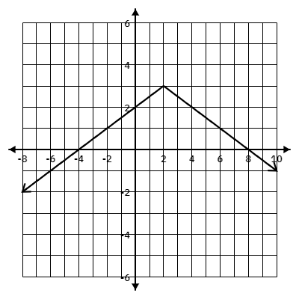
- Using the graph provided answer the following:
  - Domain:________________
  - Range: _________________
  - Min/Max: _______________
  - Vertex: _________________
  - X-int(s): ________________
  - Y-int: __________________

  - Verbal Description:___________________________________ __________________________________________________

- $f(x)= |x+9|-4$
  - Domain:________________
  - Range: _________________
  - Min/Max: _______________
  - Vertex: _________________
  - X-int(s): ________________
  - Y-int: __________________
  - Verbal Description: ___________________________________ ___________________________________________________

- $f(x)= \frac{1}{2}|x-5|-2$
  - Domain:________________
  - Range: _________________
  - Min/Max: _______________
  - Vertex: _________________
  - X-int(s): ________________
  - Y-int: __________________

  - Verbal Description: ___________________________________ ___________________________________________________

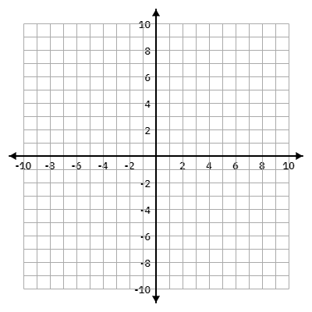
- $f(x)≤ -3|x+2|+6$

6C. The function $f(x)=|x|$ is transformed to form a new function $g(x)$, which contains the following:
- Vertical shift 5 units down
- Horizontal shift 2 units to the left
- Point at $(0,-3)$

What is the equation for $g(x)$?

__________________________________

